**VISVESVARAYA TECHNOLOGICAL UNIVERSITY**



**“JnanaSangama”, Belgaum -590014, Karnataka.**

## LAB REPORT

**on**

OBJECT ORIENTED JAVA PROGRAMMING

***Submitted by***

**SANA SUBODH**

**(1BM23CS296)**

***in partial fulfillment for the award of the degree of***

**BACHELOR OF ENGINEERING**

***in***

## COMPUTER SCIENCE AND ENGINEERING

**B.M.S. COLLEGE OF ENGINEERING**

**(Autonomous Institution under VTU)**

**BENGALURU-560019 Sep 2024-Jan 2025**

**B. M. S. College of Engineering,**



**Bull Temple Road, Bangalore 560019**

(Affiliated To Visvesvaraya Technological University, Belgaum)

**Department of Computer Science and Engineering**

#### CERTIFICATE

This is to certify that the Lab work entitled “**OBJECT ORIENTED JAVA PROGRAMMING**” carried out by **SANA SUBODH(1BM23CS296),** who is bonafide student of **B. M. S. College of Engineering.** It is in partial fulfillment for the award of **Bachelor of Engineering in Computer Science and Engineering** of the Visvesvaraya Technological University, Belgaum during the year 2024-25. The Lab report has been approved as it satisfies the academic requirements in respect of **Object-Oriented Java Programming Lab - (23CS3PCOOJ)** work prescribed for the said degree.

**Dr. Nandhini Vineeth Dr. Kavitha Sooda**

Associate Professor, Professor and Head,

Department of CSE, Department of CSE

BMSCE, Bengaluru BMSCE, Bengaluru

**INDEX**

|  |  |  |  |
| --- | --- | --- | --- |
| **Sl. No.** | **Date** | **Experiment Title** | **Page No.** |
| 1 | 26/09/24 | Quadratic Equations | 4 |
| 2 | 03/10/24 | Student SGPA | 8 |
| 3 | 19/10/24 | Book Details | 13 |
| 4 | 24/10/24 | Area Of The Space | 17 |
| 5 | 07/11/24 | Bank | 21 |
| 6 | 14/11/24 | Packages | 31 |
| 7 | 21/11/24 | Exception Handling Inheritance | 42 |
| 8 | 28/11/24 | Threads | 48 |
| 9 | 24/12/24 | Open ended(1) | 52 |
| 10 | 24/12/24 | Open ended(2) | 54 |

**Github Link :** https://github.com/SANASUBODH/296JAVA

#### LAB 01:

Develop a Java program that prints all real solutions to the quadratic equation ax2 +bx+c = 0. Read in a, b, c and use the quadratic formula. If the discriminate b2 -4ac is negative, display a message stating that there are no real solutions.

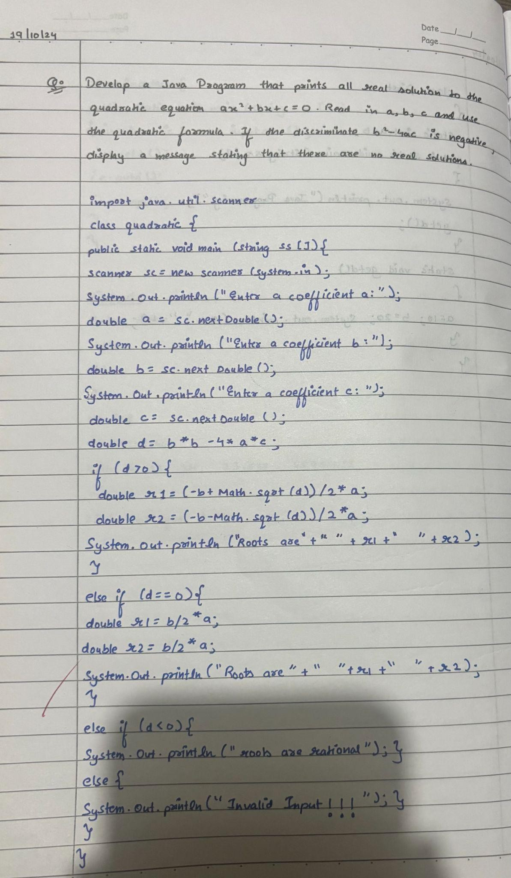

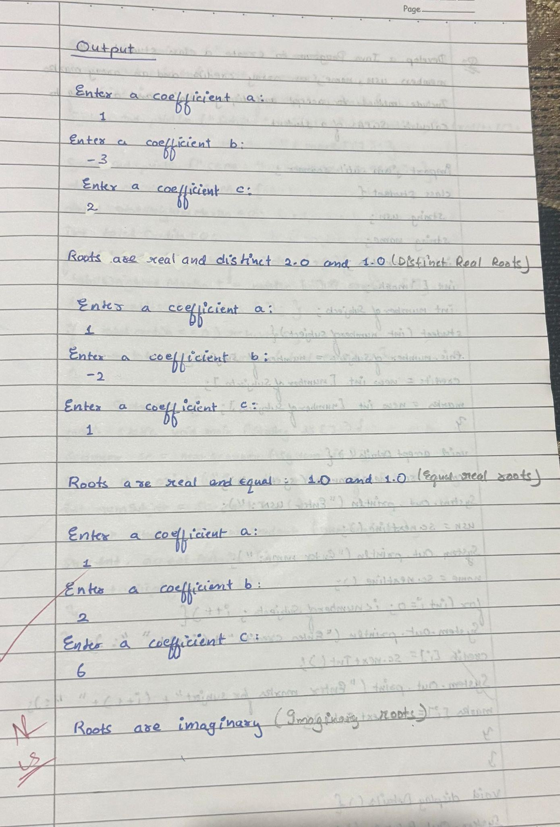

import java.util.*;

class Quadratic {

public static void main(String args[]) { Scanner input = new Scanner(System.in);

System.out.println("Enter coefficient of a:"); double a = input.nextDouble();

// Handling the case where 'a' is zero if (a == 0) {

System.out.println("This is not a quadratic equation (a cannot be zero)."); return; // Exit the program as the equation is invalid

}

System.out.println("Enter coefficient of b:"); double b = input.nextDouble();

System.out.println("Enter coefficient of c:"); double c = input.nextDouble();

// Calculating the discriminant double d = b * b - 4 * a * c;

if (d > 0) {

// Two real and distinct roots

double r1 = (-b + Math.sqrt(d)) / (2 * a); double r2 = (-b - Math.sqrt(d)) / (2 * a);

System.out.println("Roots are real and distinct: " + r1 + " and " + r2);

} else if (d == 0) {

// One real root

double r1 = -b / (2 * a);

System.out.println("Root is real and repeated: " + r1);

} else {

// Complex roots

double realPart = -b / (2 * a);

double imaginaryPart = Math.sqrt(-d) / (2 * a);

System.out.println("Roots are complex: " + realPart + " + " + imaginaryPart + "i and "

+ realPart + " - " + imaginaryPart + "i");

}

}

}

Output:

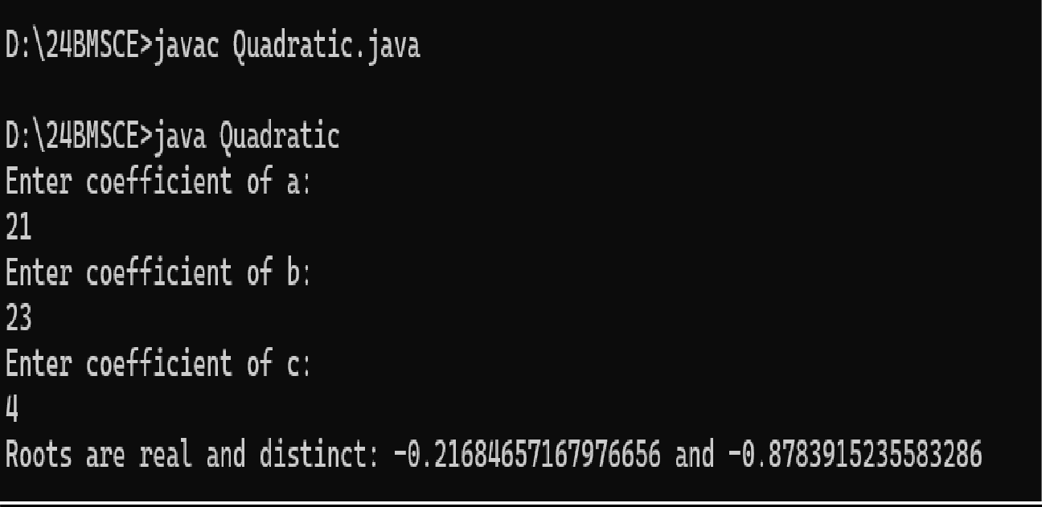

#### LAB 02 :

Develop a Java program to create a class Student with members usn, name, an array credits and an array marks. Include methods to accept and display details and a method to calculate SGPA of a student.

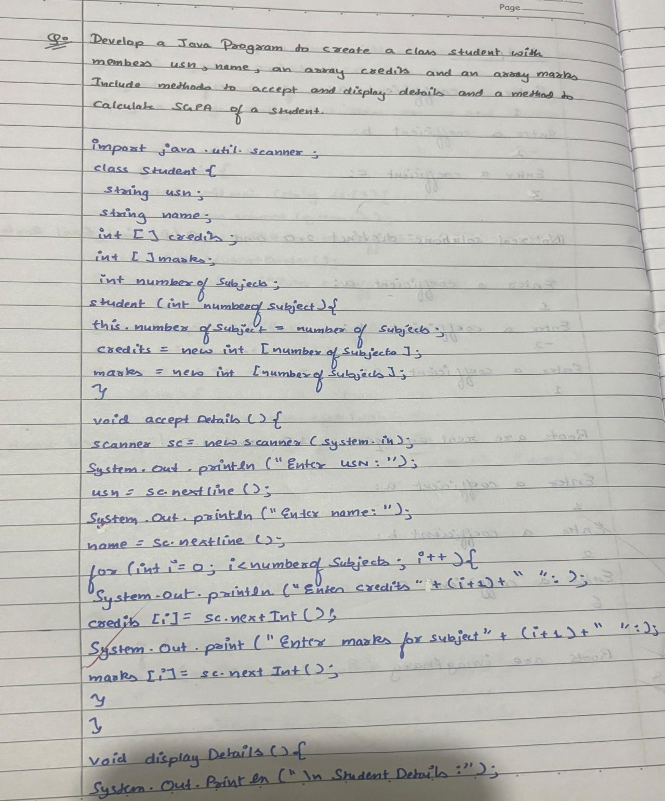

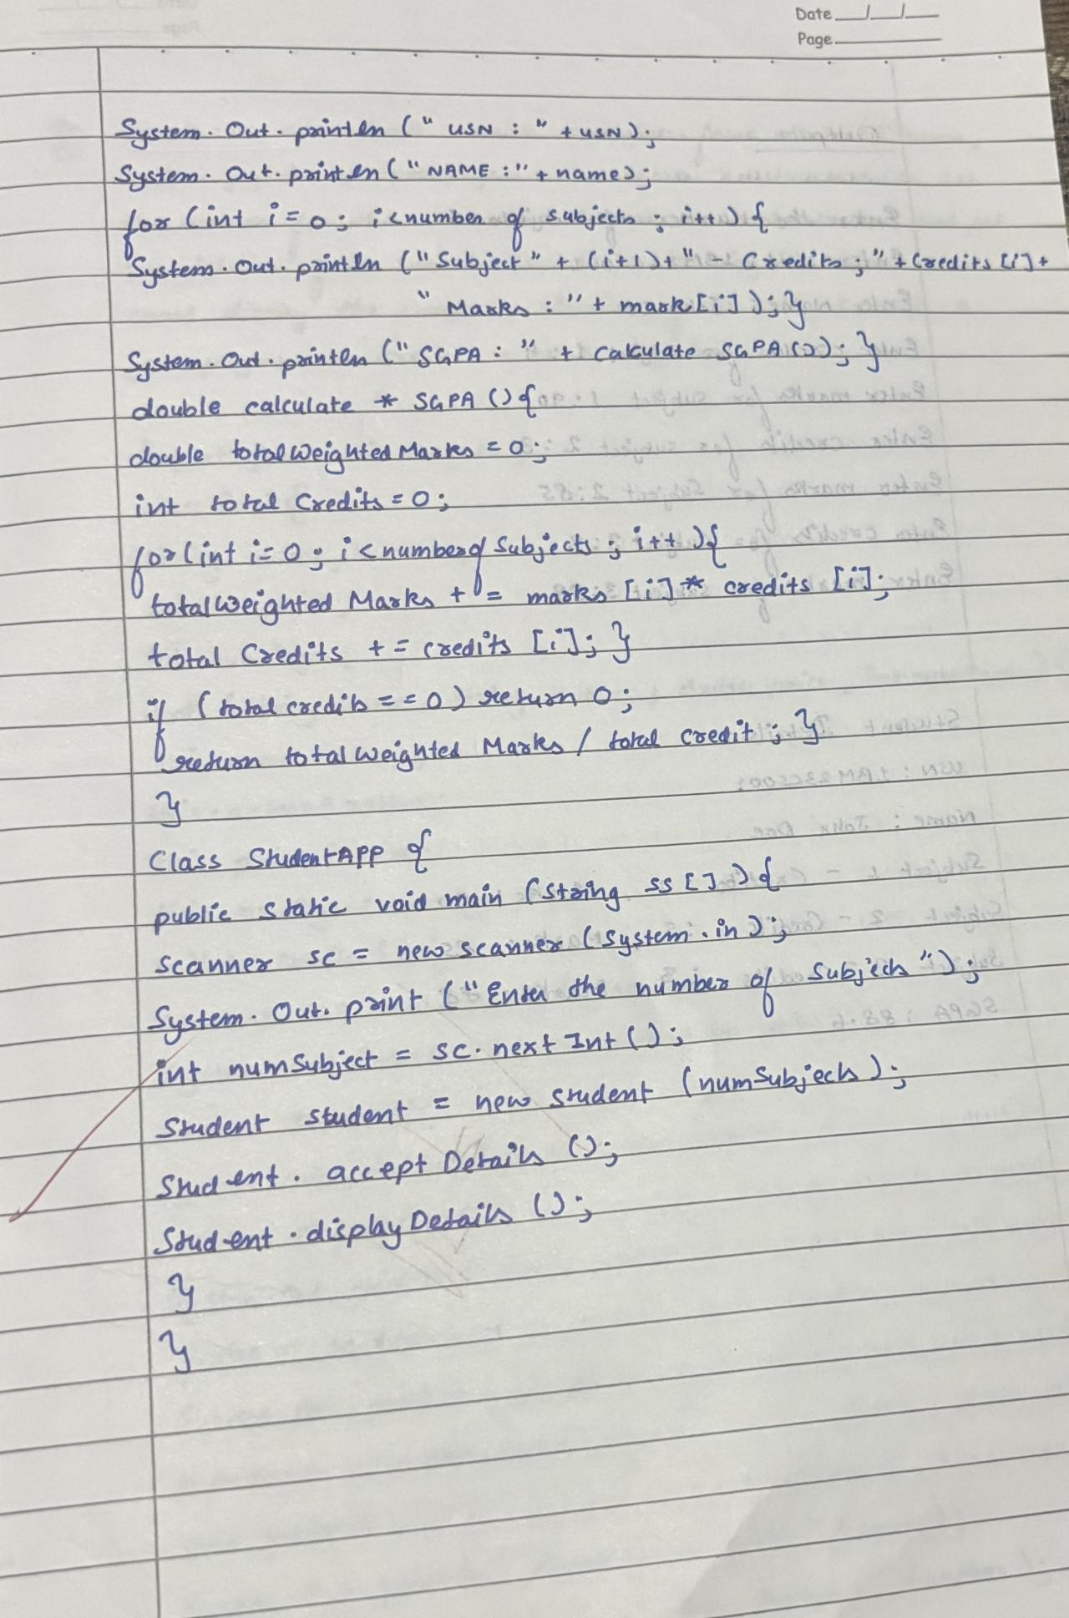

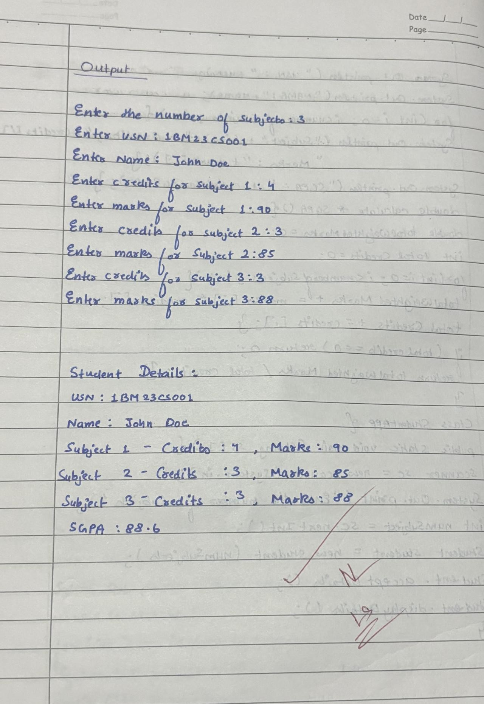

import java.util.Scanner; class Student{

String usn; String name; int[] credits; int[] marks;

int numberofSubjects; Student(int numberofSubjects){

this.numberofSubjects=numberofSubjects; credits=new int[numberofSubjects]; marks=new int[numberofSubjects];

}

void acceptDetails(){

Scanner sc=new Scanner(System.in); System.out.println("ENTER USN:"); usn=sc.nextLine(); System.out.println("ENTER NAME:"); name=sc.nextLine();

for(int i=0;i<numberofSubjects;i++){ System.out.println("ENTER CREDITS:"+(i+1)); credits[i]=sc.nextInt(); System.out.println("ENTER MARKS:"+(i+1)); marks[i]=sc.nextInt();

}}

void displayDetails(){

System.out.println("\n STUDENT DETAILS:"); System.out.println("USN:"+usn); System.out.println("NAME:"+name);

for(int i=0;i<numberofSubjects;i++){

System.out.println("SUBJECT"+(i+1)+" "+"CREDITS:"+credits[i]+" "+"MARKS:"+marks[i]);}

System.out.println("SGPA:"+calculateSGPA());} double calculateSGPA(){

double totalWeightedMarks=0; int totalCredits=0;

for(int i=0;i<numberofSubjects;i++){ totalWeightedMarks+=marks[i]*credits[i]; totalCredits+=credits[i];} if(totalCredits==0)

return 0;

return totalWeightedMarks/totalCredits;}

}

class StudentApp{

public static void main(String ss[]){ Scanner sc=new Scanner(System.in);

System.out.println("Enter the number of subjects:"); int numSubjects=sc.nextInt();

Student student=new Student(numSubjects); student.acceptDetails(); student.displayDetails();

}

}

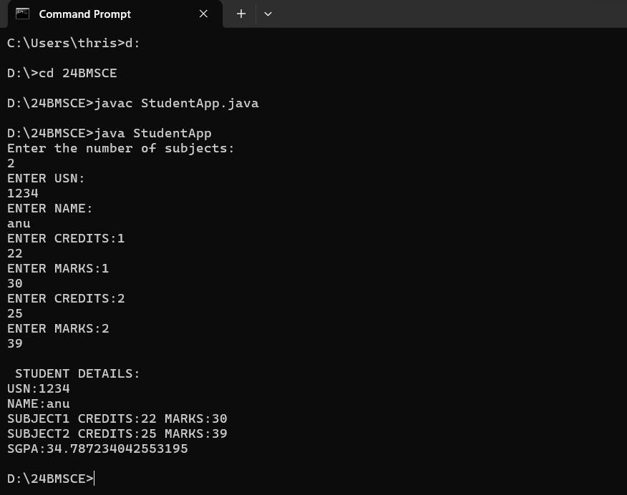

#### LAB 03

Create a class Book which contains four members: name, author, price, num_pages. Include a constructor to set the values for the members. Include methods to set and get the details of the objects. Include a toString( ) method that could display the complete details of the book.

Develop a Java program to create n book objects.

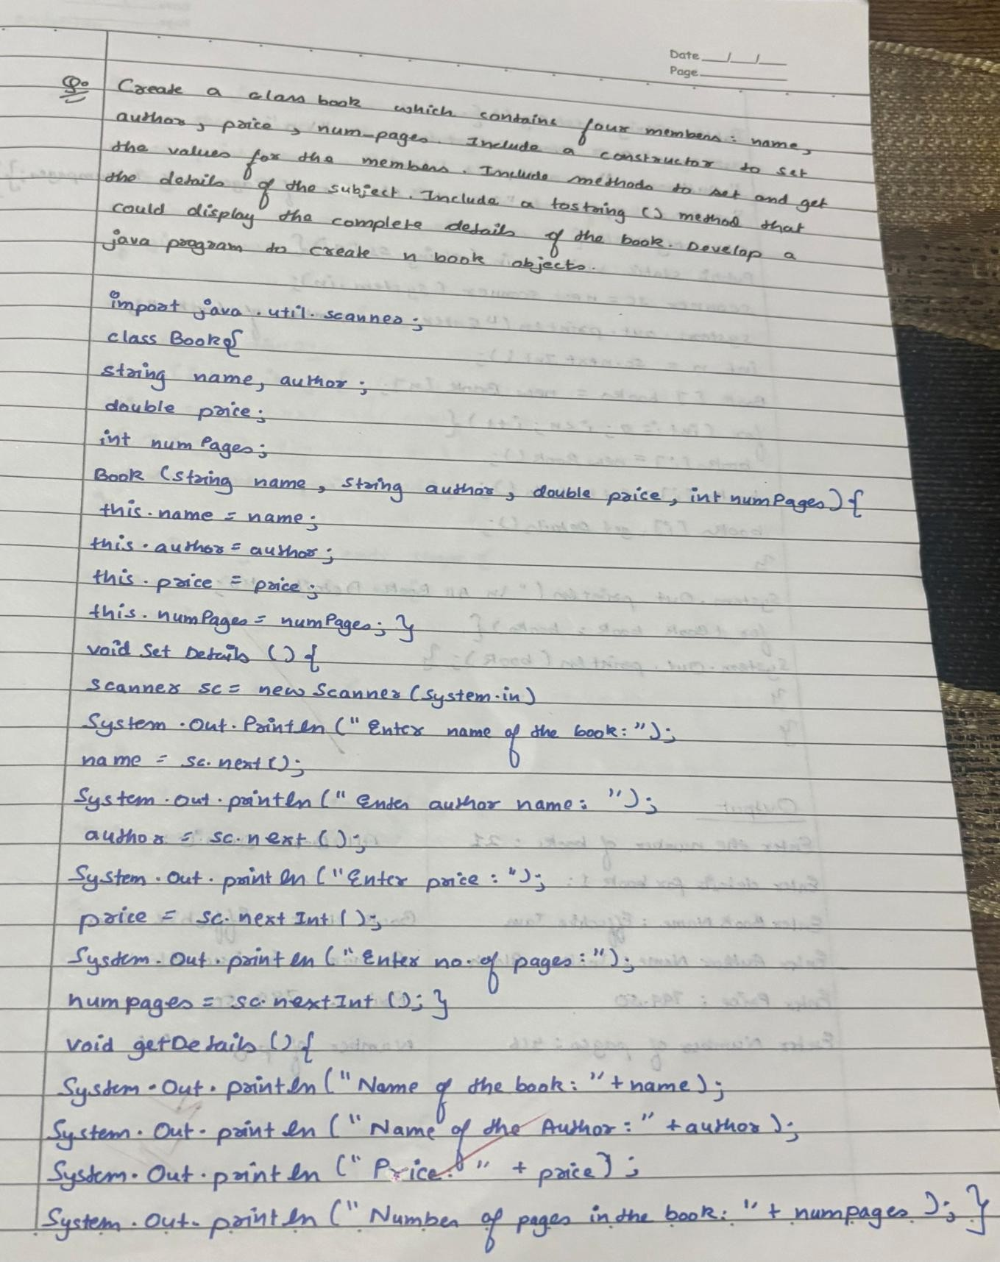

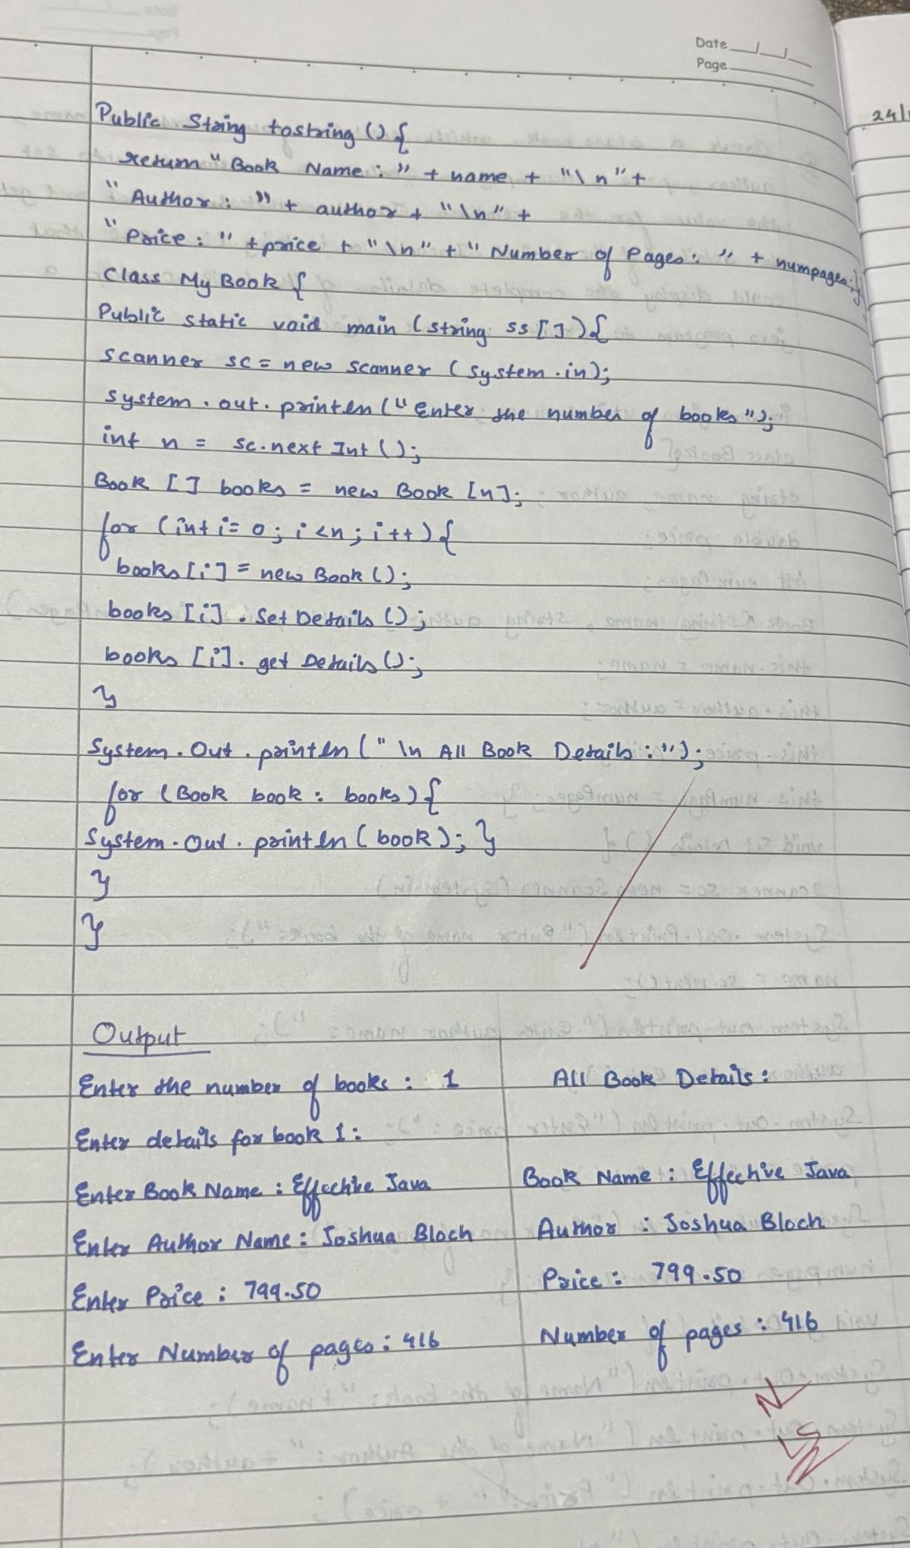

import java.util.Scanner; class Book{

String name,author; double price;

int numPages;

Book(String name,String auhtor,double price,int numPages){ this.name=name;

this.author=author; this.price=price; this.numPages=numPages;} void setDetails(){

Scanner sc=new Scanner(System.in); System.out.println("enter name of the book:"); name=sc.next();

System.out.println("enter author of the book:"); author=sc.next();

System.out.println("enter price of the book:"); price=sc.nextInt();

System.out.println("enter number of pages of the book:"); numPages=sc.nextInt();}

void getDetails(){

System.out.println("Name of the book:"+name); System.out.println("Author of the book:"+author); System.out.println("Price of the book:"+price); System.out.println("Number of pages of the book:"+numPages);} public String toString(){

return "Book Name:"+name+"\n"+"Author:"+author+"\n"+"price:"+price+"\n"+"Number of pages:"+numPages;}

}

class MyBook{

public static void main(String ss[]){

Scanner sc=new Scanner(System.in); System.out.println("Enter the number of books"); int n=sc.nextInt();

Book[] books=new Book[n]; for(int i=0;i<n;i++){

books[i]=new Book("time","gallium",99,150); books[i].setDetails();

books[i].getDetails();

}

System.out.println("\n All book details:"); for(Book book:books){ System.out.println(book); System.out.println();

}

}

}

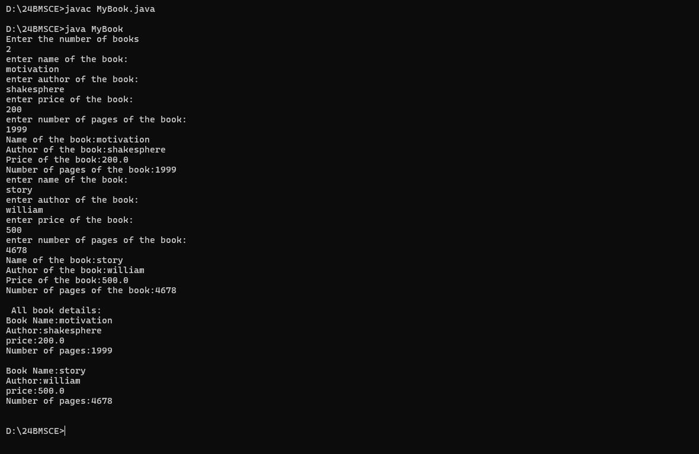

**LAB 04**

### Develop a Java program to create an abstract class named Shape that contains two integers and an empty method named printArea(). Provide three classes named Rectangle, Triangle and Circle such that each one of the classes extends the class Shape. Each one of the classes contain only the method printArea() that prints the area of the given shape.

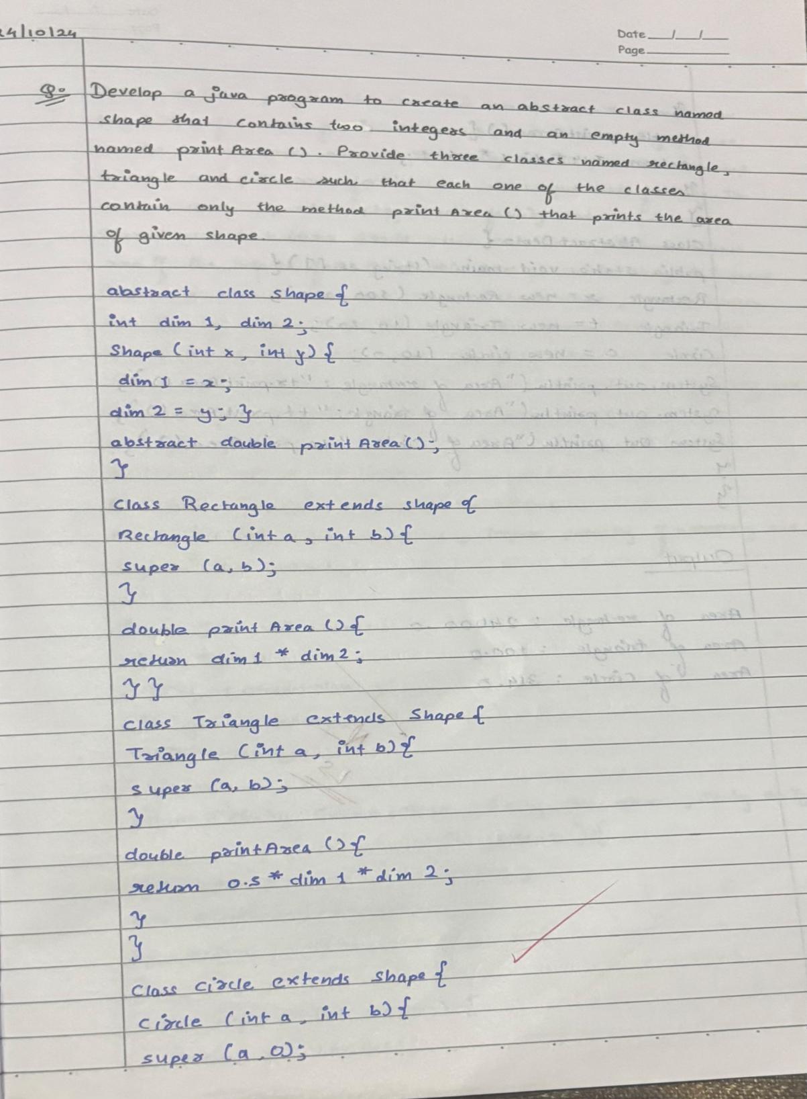

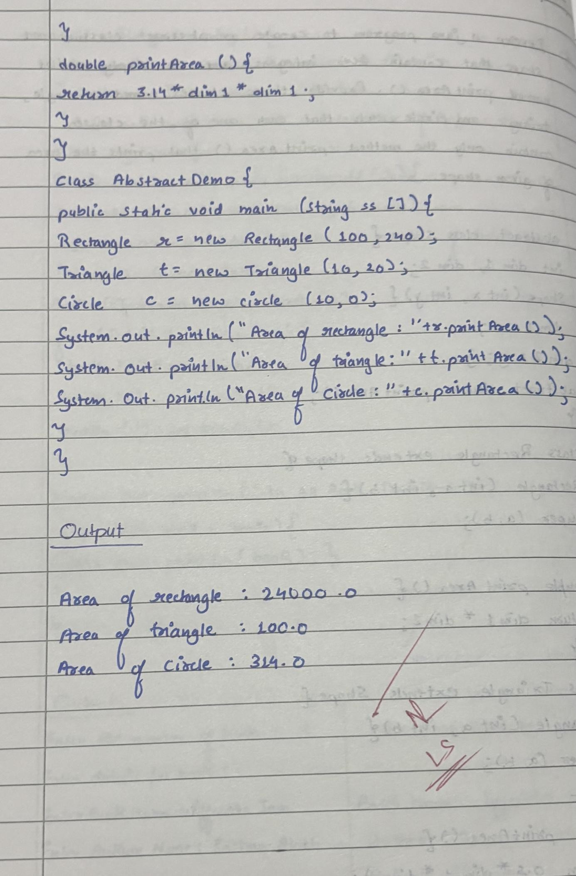

abstract class Shape{ int dim1,dim2; Shape(int x,int y){ dim1=x;

dim2=y;}

abstract double printArea();

}

class Rectangle extends Shape{ Rectangle(int a,int b){ super(a,b);

}

double printArea(){ return dim1*dim2;

}}

class Triangle extends Shape{ Triangle(int a,int b){ super(a,b);

}

double printArea(){ return 0.5*dim1*dim2;

}

}

class Circle extends Shape{ Circle (int a,int b){ super(a,0);

}

double printArea(){ return 3.14*dim1*dim1;

}

}

class AbstractDemo{

public static void main(String ss[]){ Rectangle r=new Rectangle(100,240); Triangle t=new Triangle(10,20); Circle c =new Circle(10,0);

System.out.println("Area of rectangle:"+r.printArea()); System.out.println("Area of triangle:"+t.printArea()); System.out.println("Area of circle:"+c.printArea());

}

}

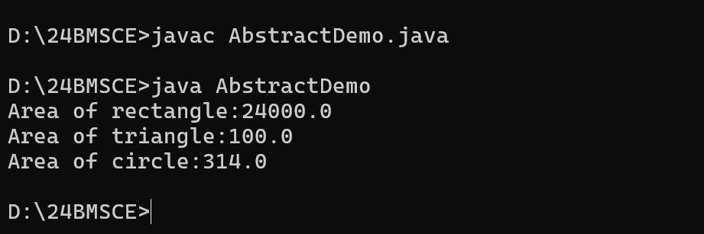

**LAB 05**

### Develop a Java program to create a class Bank that maintains two kinds of account for its customers, one called savings account and the other current account. The savings account provides compound interest and withdrawal facilities but no cheque book facility. The current account provides cheque book facility but no interest. Current account holders should also maintain a minimum balance and if the balance falls below this level, a service charge is imposed. Create a class Account that stores customer name, account number and type of account. From this derive the classes Cur-acct and Sav-acct to make them more specific to their requirements. Include the necessary methods in order to achieve the following tasks: a) Accept deposit from customer and update the balance. b) Display the balance. c) Compute and deposit interest d) Permit withdrawal and update the balance Check for the minimum balance, impose penalty if necessary and update the balance.

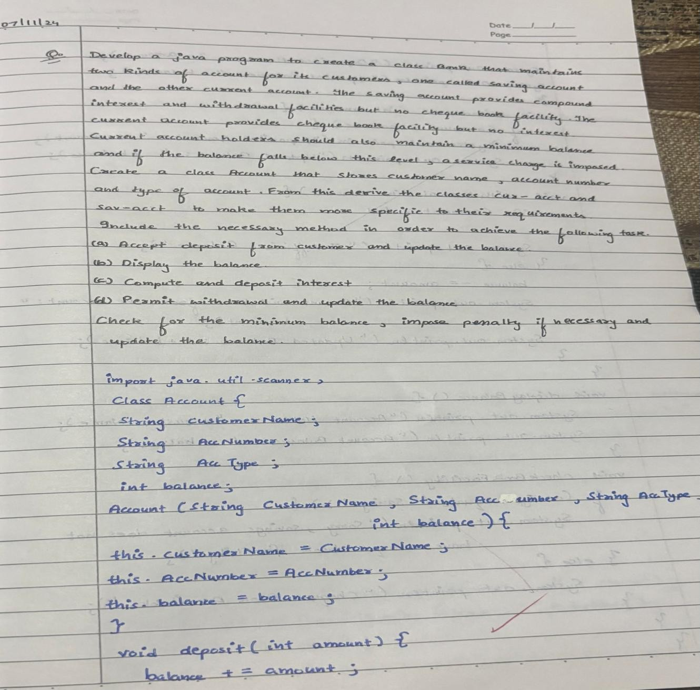

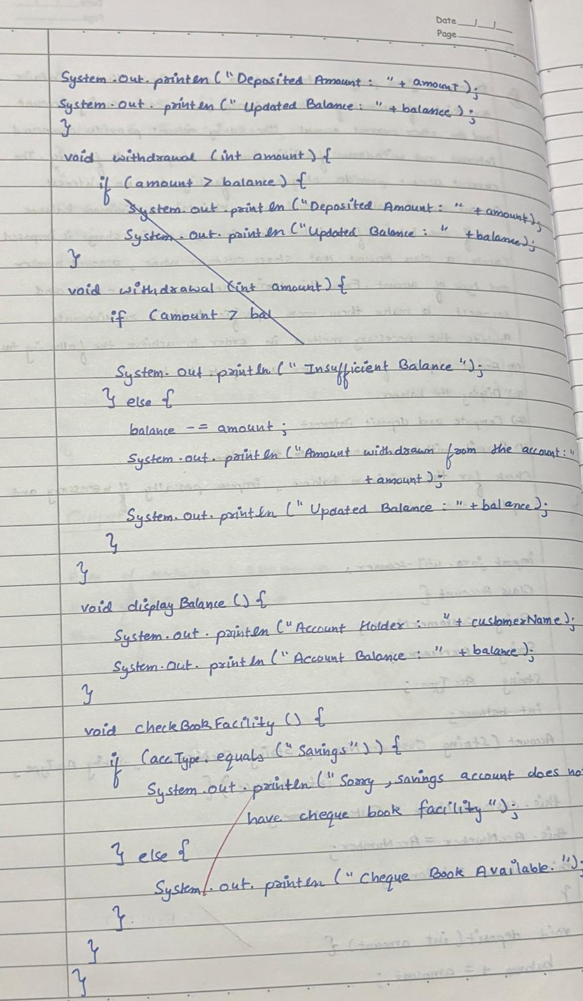

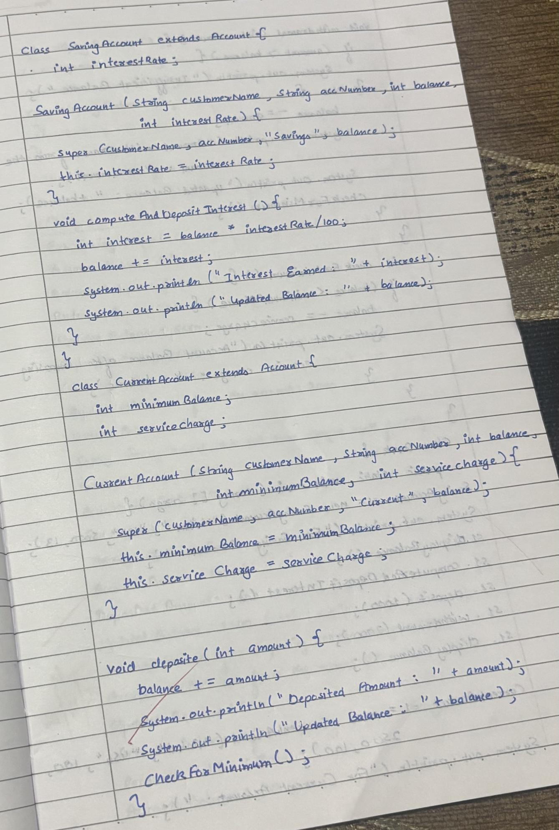

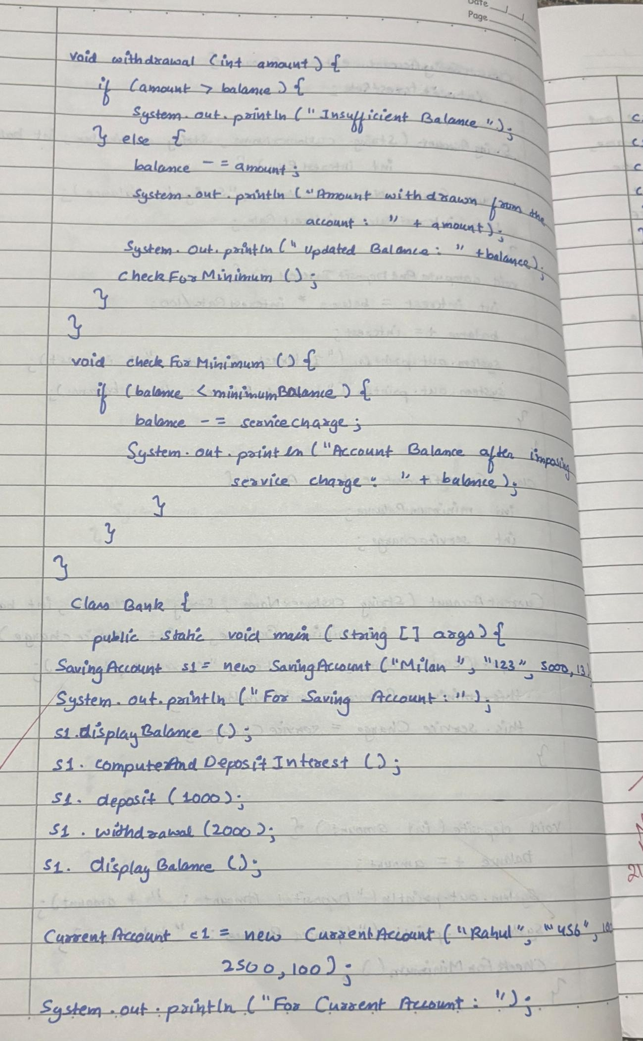

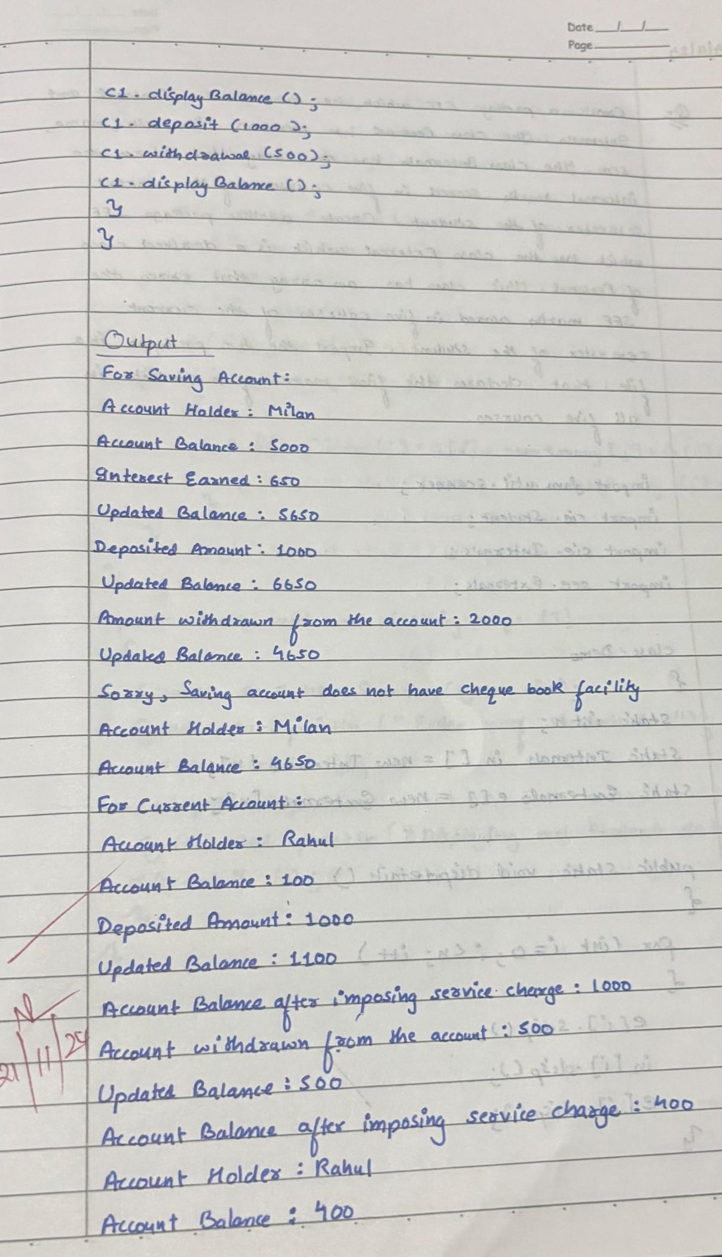

import java.util.Scanner;

abstract class Account {

String customerName, accountNumber; double balance;

Account(String customerName, String accountNumber, double initialBalance) { this.customerName = customerName;

this.accountNumber = accountNumber; this.balance = initialBalance;

}

abstract void deposit(double amount); abstract void displayBalance();

abstract void withdraw(double amount);

}

class SavAcct extends Account { double interestRate;

SavAcct(String customerName, String accountNumber, double initialBalance, double interestRate) {

super(customerName, accountNumber, initialBalance); this.interestRate = interestRate;

}

void deposit(double amount) { balance += amount;

}

void displayBalance() {

System.out.println("Savings Balance: " + balance);

}

void withdraw(double amount) {

if (amount <= balance) balance -= amount;

}

void computeAndDepositInterest() { balance += balance * interestRate / 100;

}

}

class CurAcct extends Account {

static final double MIN_BALANCE = 1000, SERVICE_CHARGE = 50;

CurAcct(String customerName, String accountNumber, double initialBalance) { super(customerName, accountNumber, initialBalance);

}

void deposit(double amount) { balance += amount;

}

void displayBalance() {

System.out.println("Current Balance: " + balance);

}

void withdraw(double amount) { if (amount <= balance) {

balance -= amount;

if (balance < MIN_BALANCE) balance -= SERVICE_CHARGE;

}

}

}

class Bank {

public static void main(String[] args) { Scanner scanner = new Scanner(System.in);

System.out.println("Enter account type (savings/current): "); String type = scanner.nextLine();

System.out.println("Enter customer name: "); String name = scanner.nextLine();

System.out.println("Enter account number: "); String number = scanner.nextLine();

Account account;

if (type.equals("savings")) {

System.out.println("Initial balance and interest rate: ");

account = new SavAcct(name, number, scanner.nextDouble(), scanner.nextDouble());

} else {

System.out.println("Initial balance: ");

account = new CurAcct(name, number, scanner.nextDouble());

}

while (true) {

System.out.println("\n1. Deposit 2. Display Balance 3. Withdraw 4. Interest 5. Exit"); int choice = scanner.nextInt();

switch (choice) {

case 1: account.deposit(scanner.nextDouble()); break;

case 2: account.displayBalance(); break;

case 3: account.withdraw(scanner.nextDouble()); break;

case 4: if (account instanceof SavAcct) ((SavAcct) account).computeAndDepositInterest();

break; case 5: return;

}

}

}

}

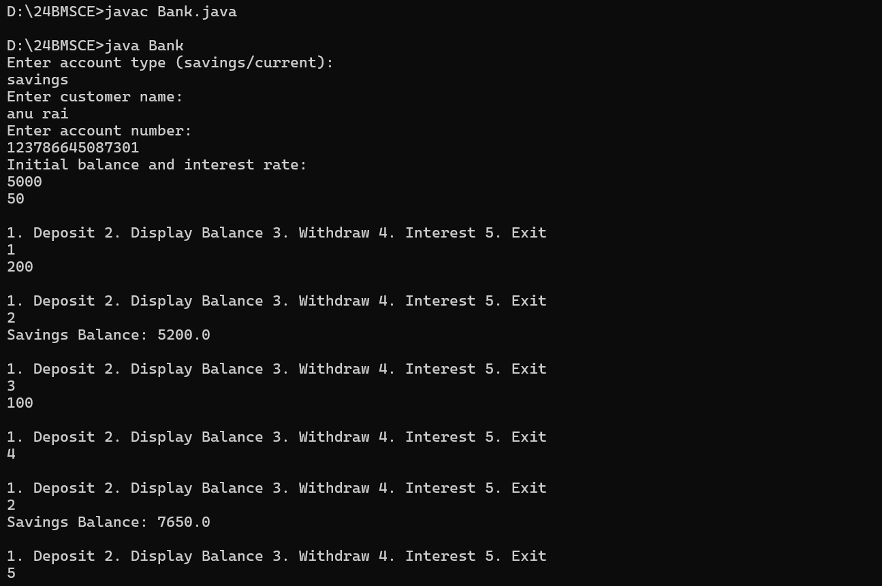

**LAB 06**

### Create a package CIE which has two classes - Personal and Internals. The class Personal has members like usn, name, sem. The class Internals has an array that stores the internal marks scored in five courses of the current semester of the student. Create another package SEE which has the class External which is a derived class of Personal. This class has an array that stores the SEE marks scored in five courses of the current semester of the student. Import the two packages in a file that declares the final marks of n students in all five courses.

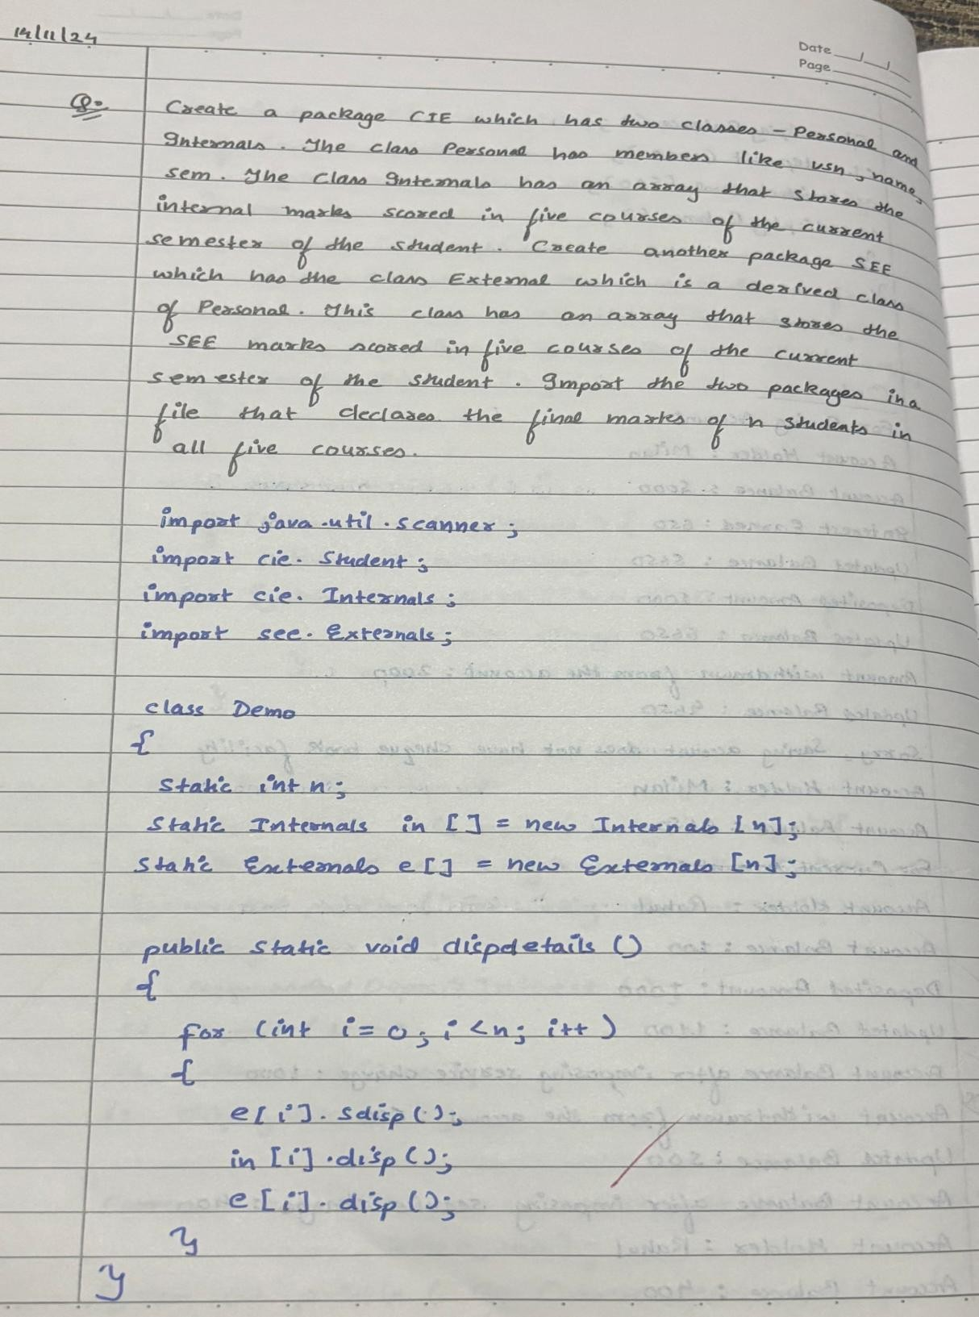

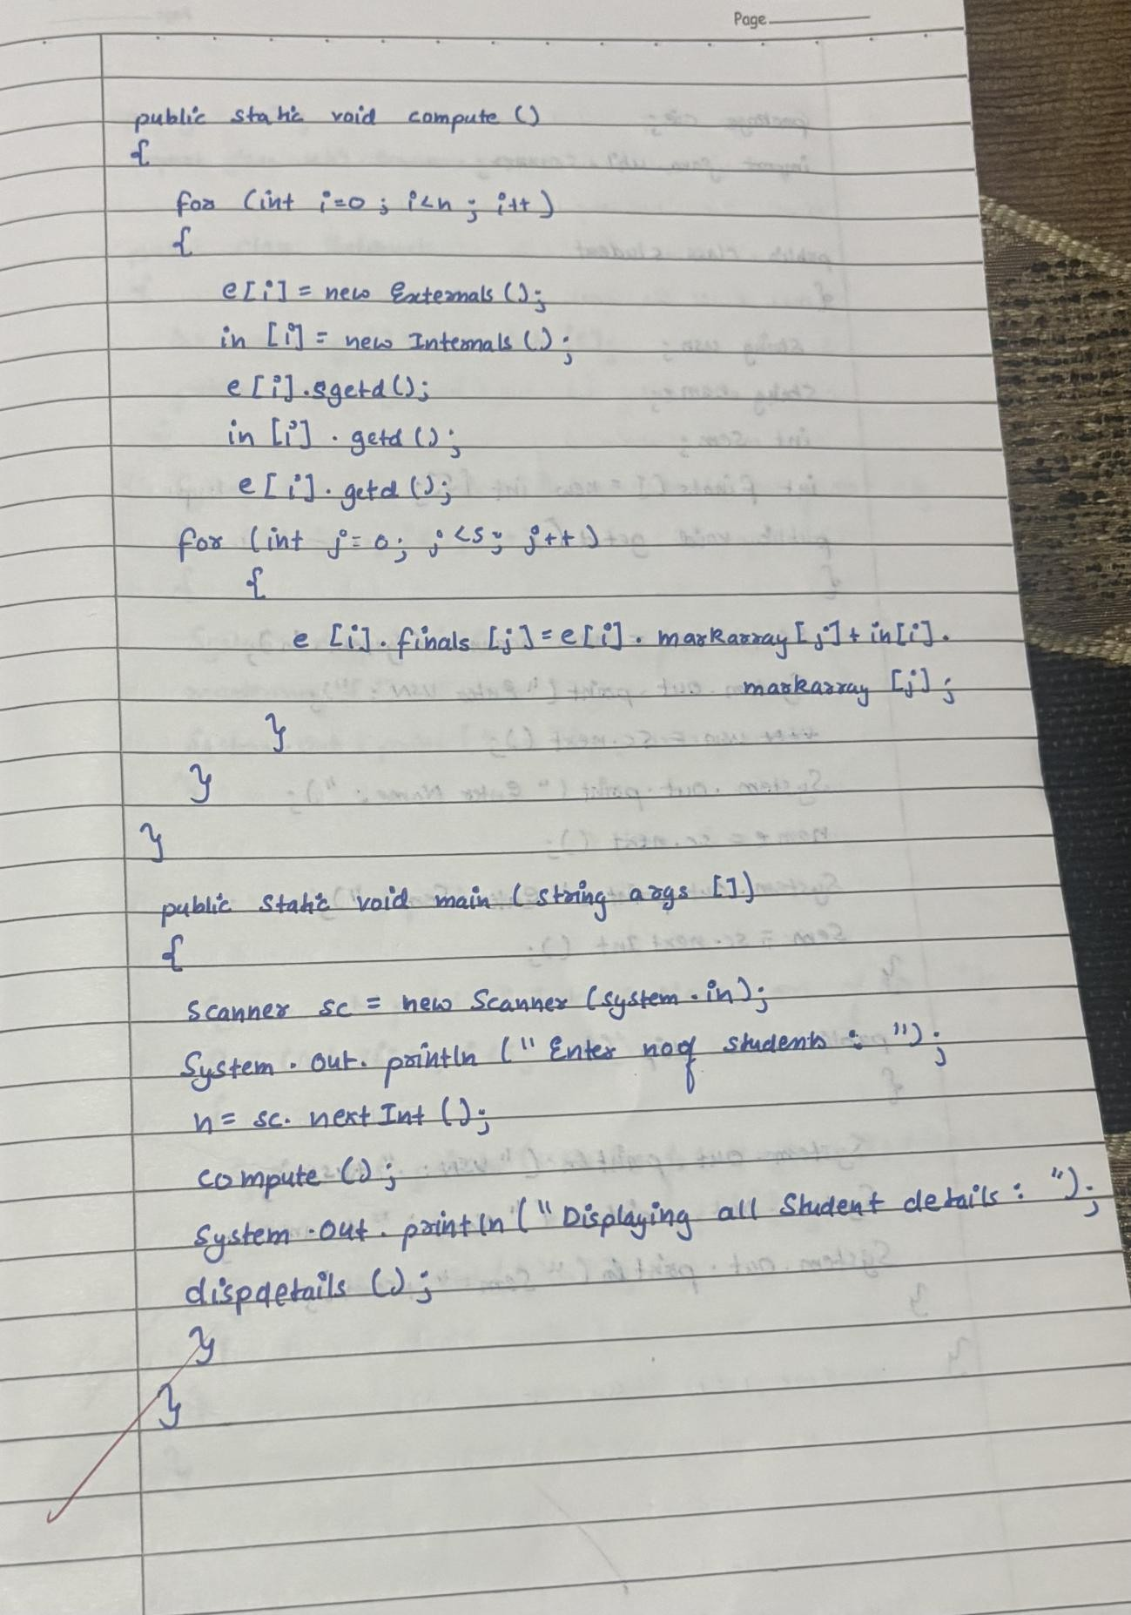

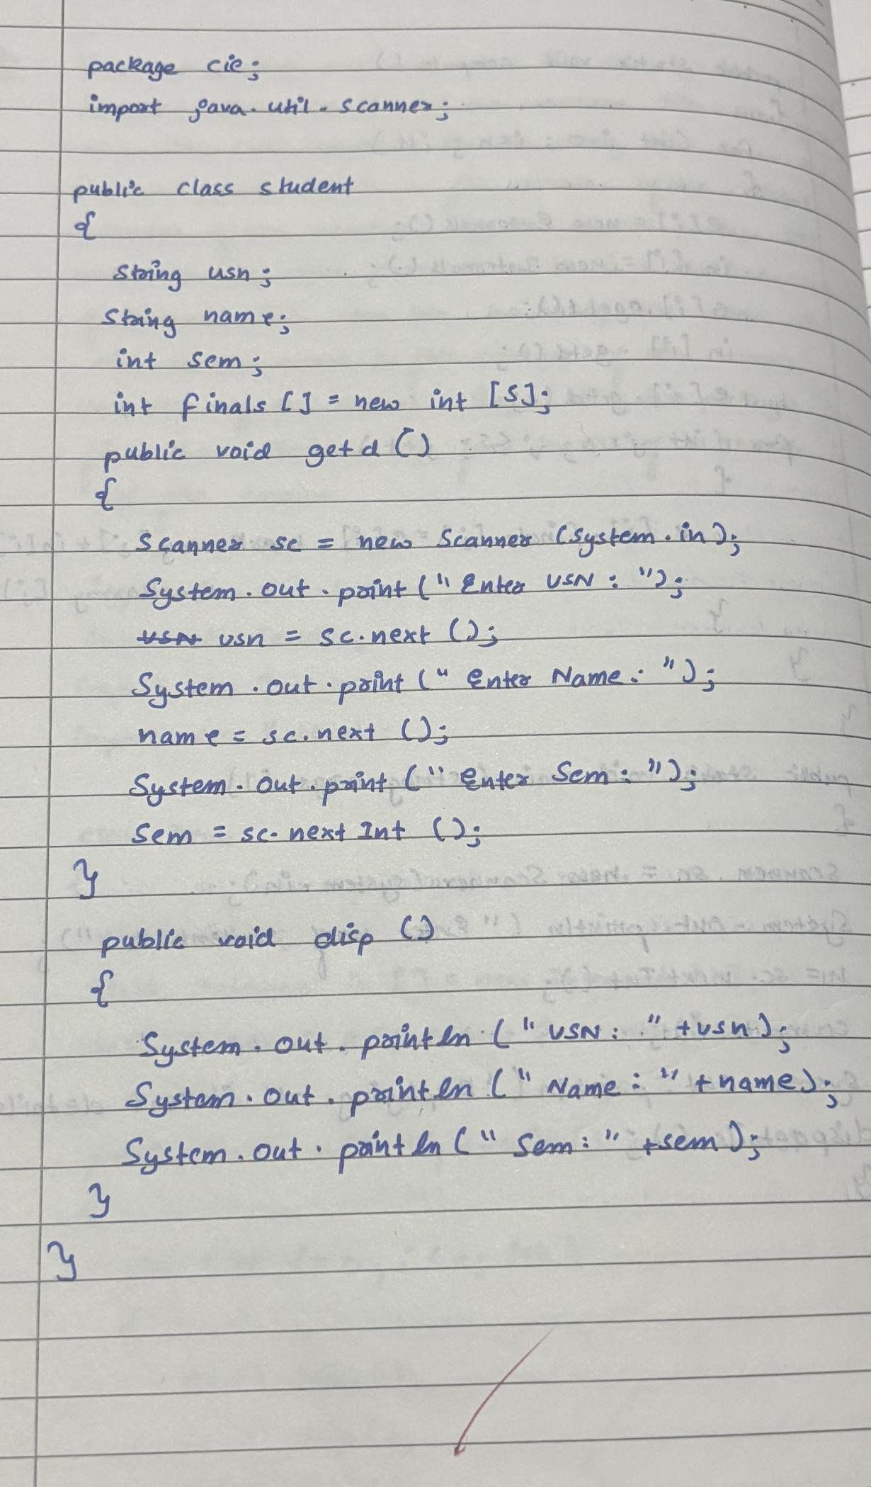

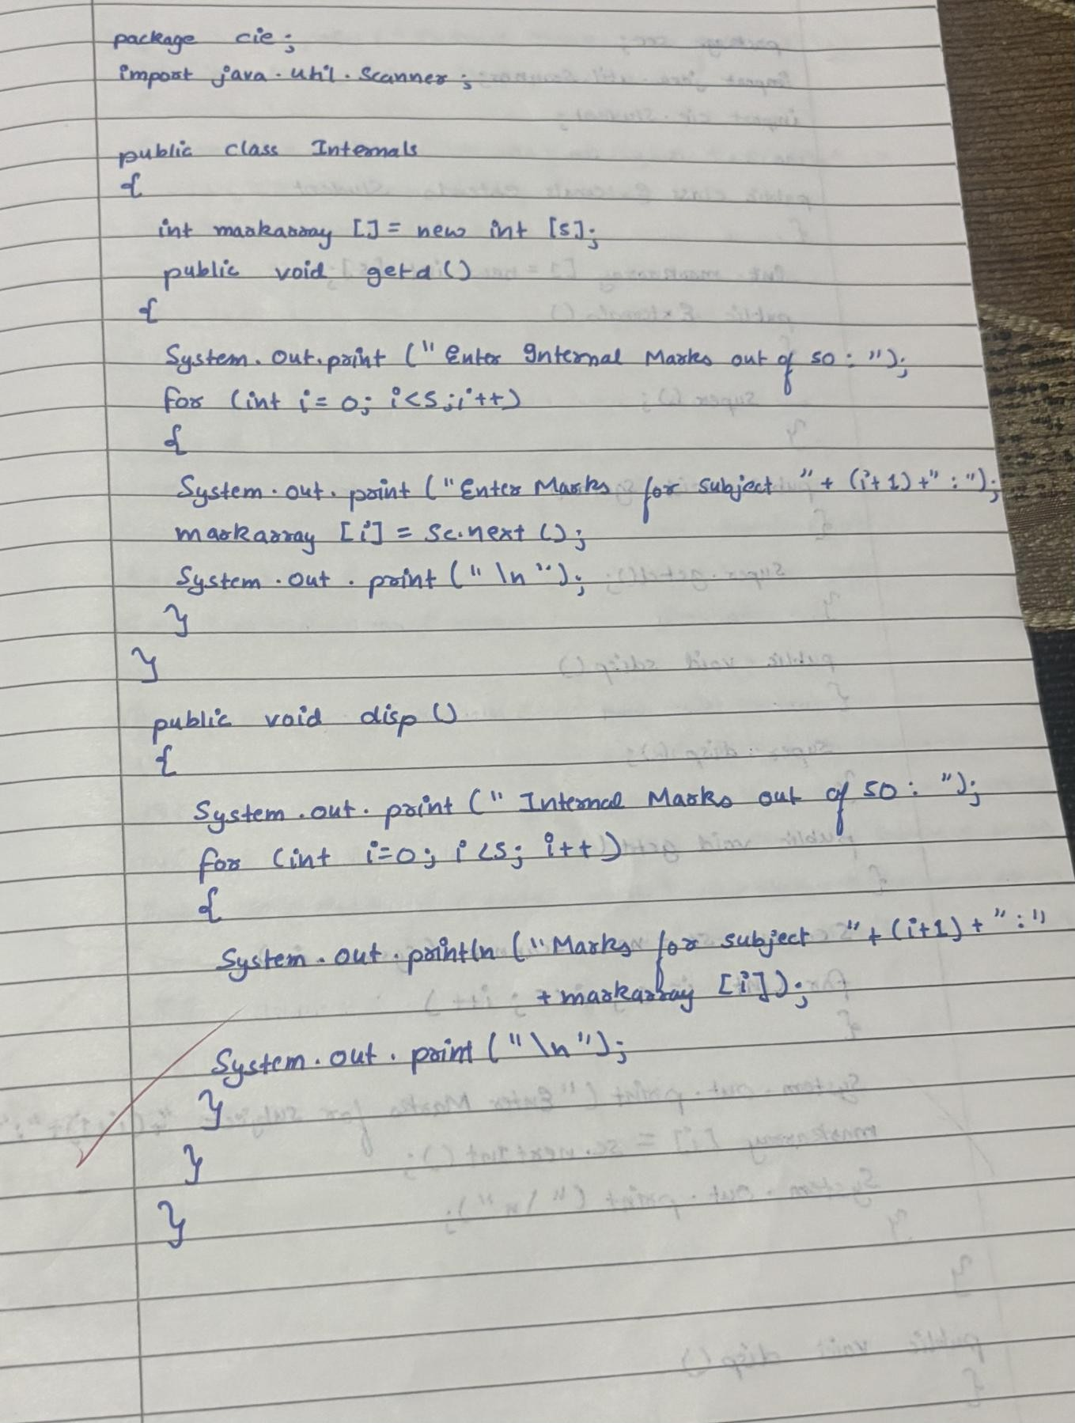

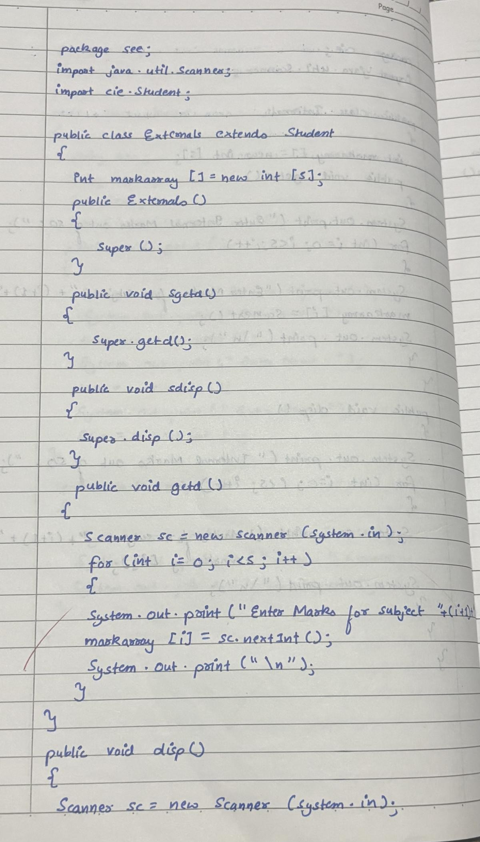

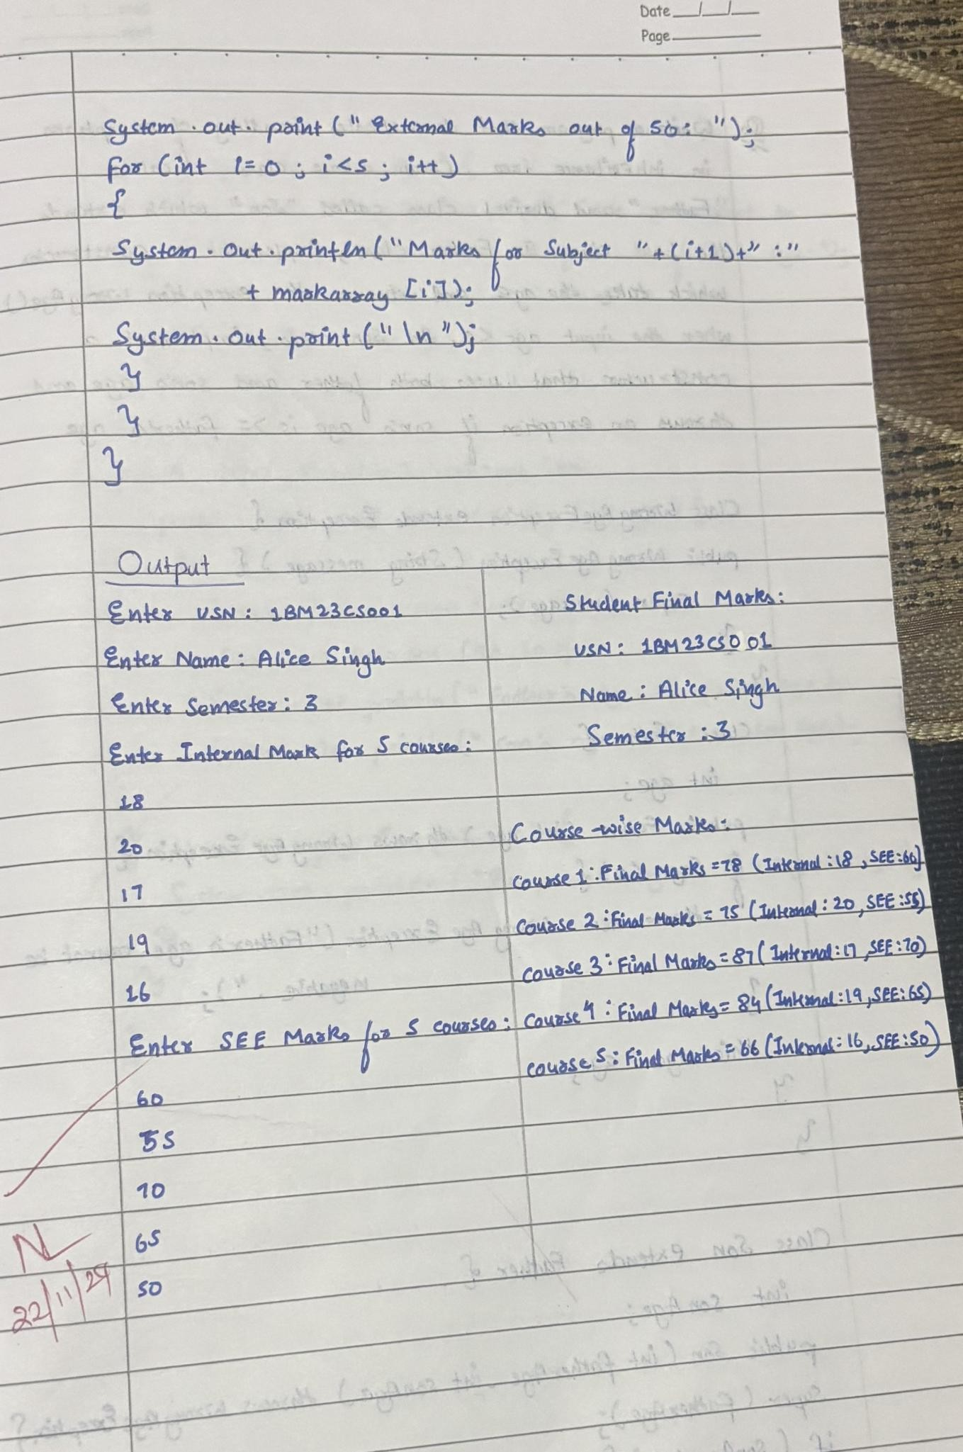

package CIE;

public class Student { private String usn; private String name; private int sem;

public Student(String usn, String name, int sem) { this.usn = usn;

this.name = name; this.sem = sem;

}

public String getUsn() { return usn;

}

public String getName() { return name;

}

public int getSem() { return sem;

}

}

package CIE;

public class Internals { private int[] internalMarks; public Internals() {

internalMarks = new int[5];

}

public void setInternalMarks(int[] marks) { if (marks.length == 5) {

this.internalMarks = marks;

} else {

System.out.println("Error: Marks should be for 5 courses.");

}

}

public int[] getInternalMarks() { return internalMarks;

}

}

package SEE; import CIE.Student;

public class External extends Student { private int[] externalMarks;

public External(String usn, String name, int sem) { super(usn, name, sem);

externalMarks = new int[5];

}

public void setExternalMarks(int[] marks) { if (marks.length == 5) {

this.externalMarks = marks;

} else {

System.out.println("Error: Marks should be for 5 courses.");

}

}

public int[] getExternalMarks() { return externalMarks;

}

public int[] getFinalMarks(int[] internalMarks) { int[] finalMarks = new int[5];

for (int i = 0; i < 5; i++) {

finalMarks[i] = internalMarks[i] + externalMarks[i];

}

return finalMarks;

}

}

import CIE.Internals; import SEE.External; import java.util.Scanner; public class Main {

public static void main(String[] args) { Scanner scanner = new Scanner(System.in);

System.out.print("Enter number of students: "); int n = scanner.nextInt();

External[] externalStudents = new External[n]; Internals[] internalMarks = new Internals[n]; for (int i = 0; i < n; i++) {

scanner.nextLine();

System.out.print("\nEnter USN for student " + (i + 1) + ": "); String usn = scanner.nextLine();

System.out.print("Enter name for student " + (i + 1) + ": "); String name = scanner.nextLine();

System.out.print("Enter semester for student " + (i + 1) + ": "); int sem = scanner.nextInt();

externalStudents[i] = new External(usn, name, sem);

internalMarks[i] = new Internals(); int[] internalMarksArray = new int[5];

System.out.println("Enter internal marks for 5 courses: "); for (int j = 0; j < 5; j++) {

internalMarksArray[j] = scanner.nextInt();

}

internalMarks[i].setInternalMarks(internalMarksArray);

int[] externalMarksArray = new int[5]; System.out.println("Enter external marks for 5 courses: "); for (int j = 0; j < 5; j++) {

externalMarksArray[j] = scanner.nextInt();

}

externalStudents[i].setExternalMarks(externalMarksArray);

}

System.out.println("\nFinal Marks for Students:"); for (int i = 0; i < n; i++) {

System.out.println("\nStudent " + (i + 1) + ": " + externalStudents[i].getName() + " ("

+ externalStudents[i].getUsn() + ")");

int[] finalMarks = externalStudents[i].getFinalMarks(internalMarks[i].getInternalMarks());

System.out.println("Semester: " + externalStudents[i].getSem()); System.out.println("Final Marks: ");

for (int j = 0; j < 5; j++) {

System.out.println("Course " + (j + 1) + ": " + finalMarks[j]);

}

}

scanner.close();

}

}

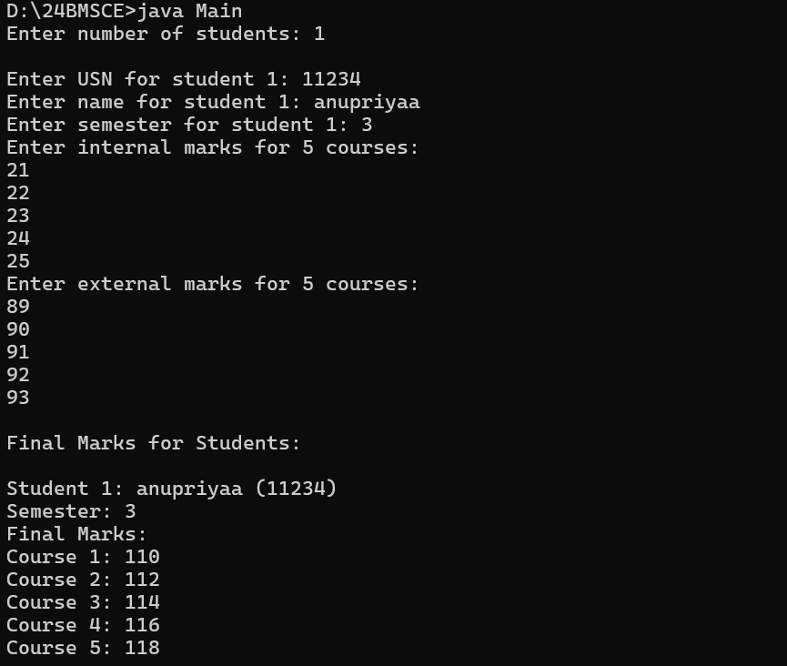

**LAB 07**

### Write a program that demonstrates handling of exceptions in inheritance tree. Create a base class called “Father” and derived class called “Son” which extends the base class. In Father class, implement a constructor which takes the age and throws the exception WrongAge( ) when the input age=father’s age.

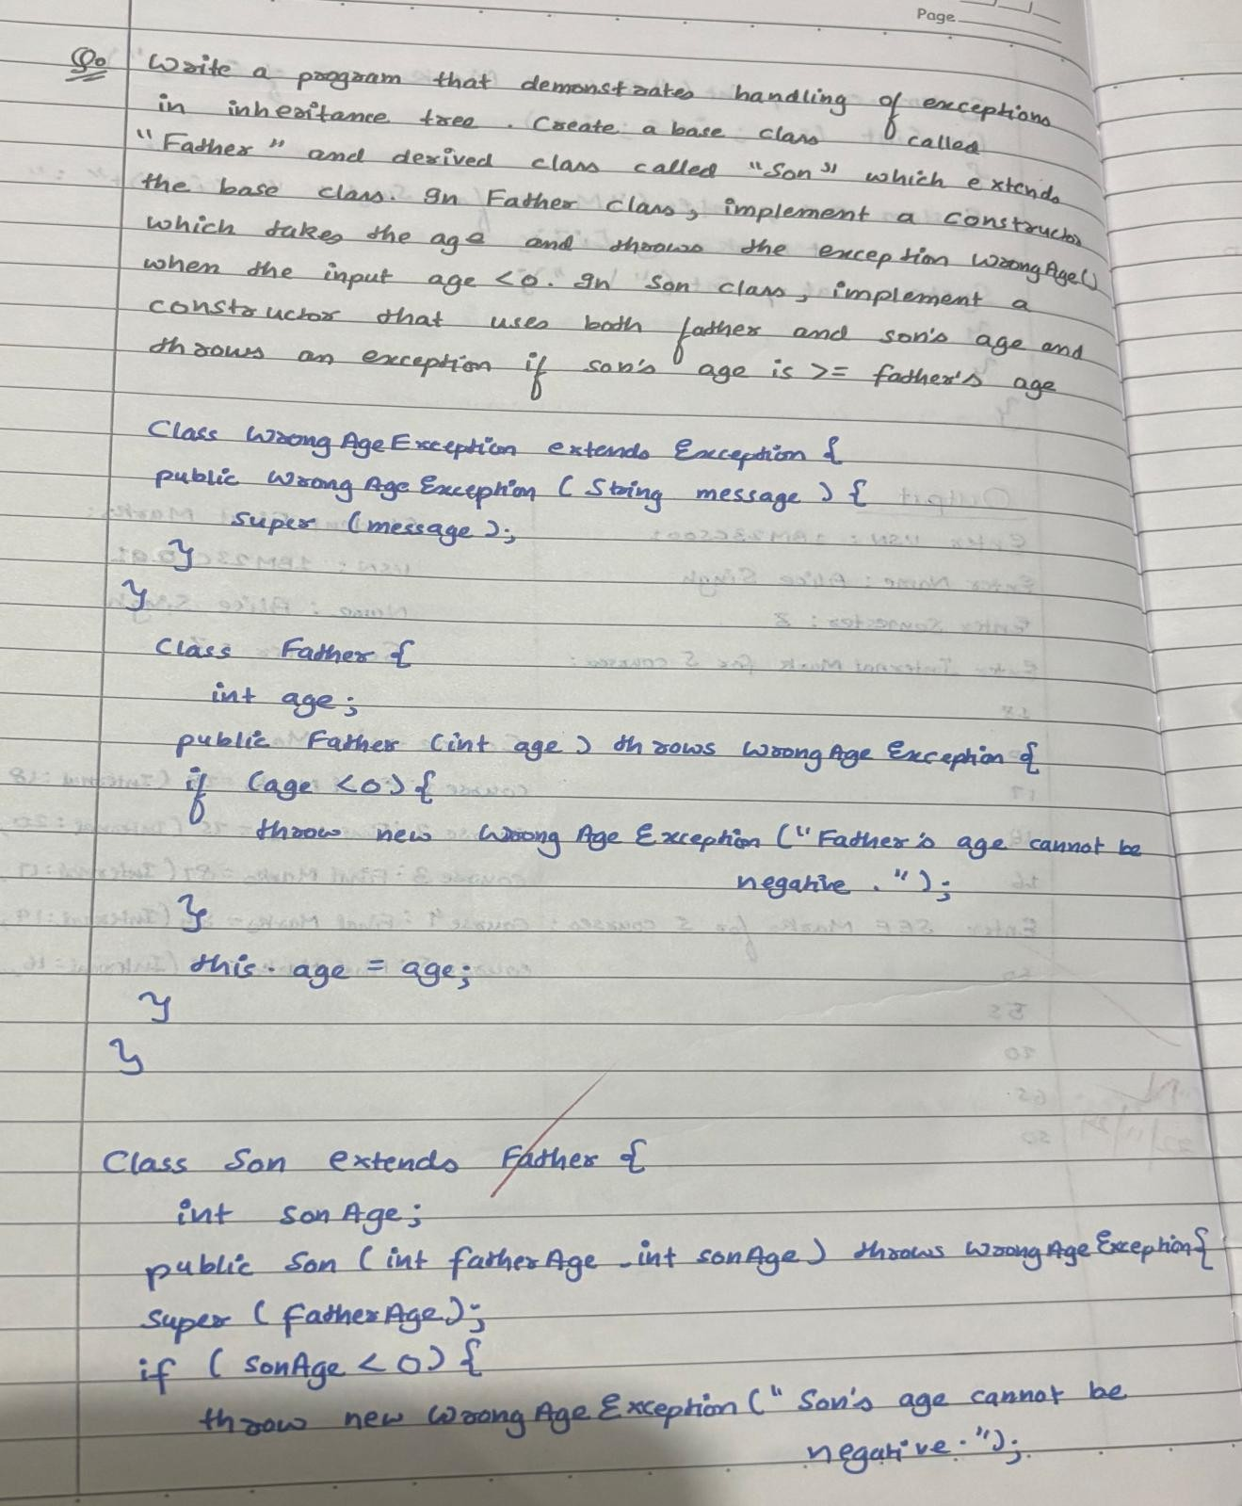

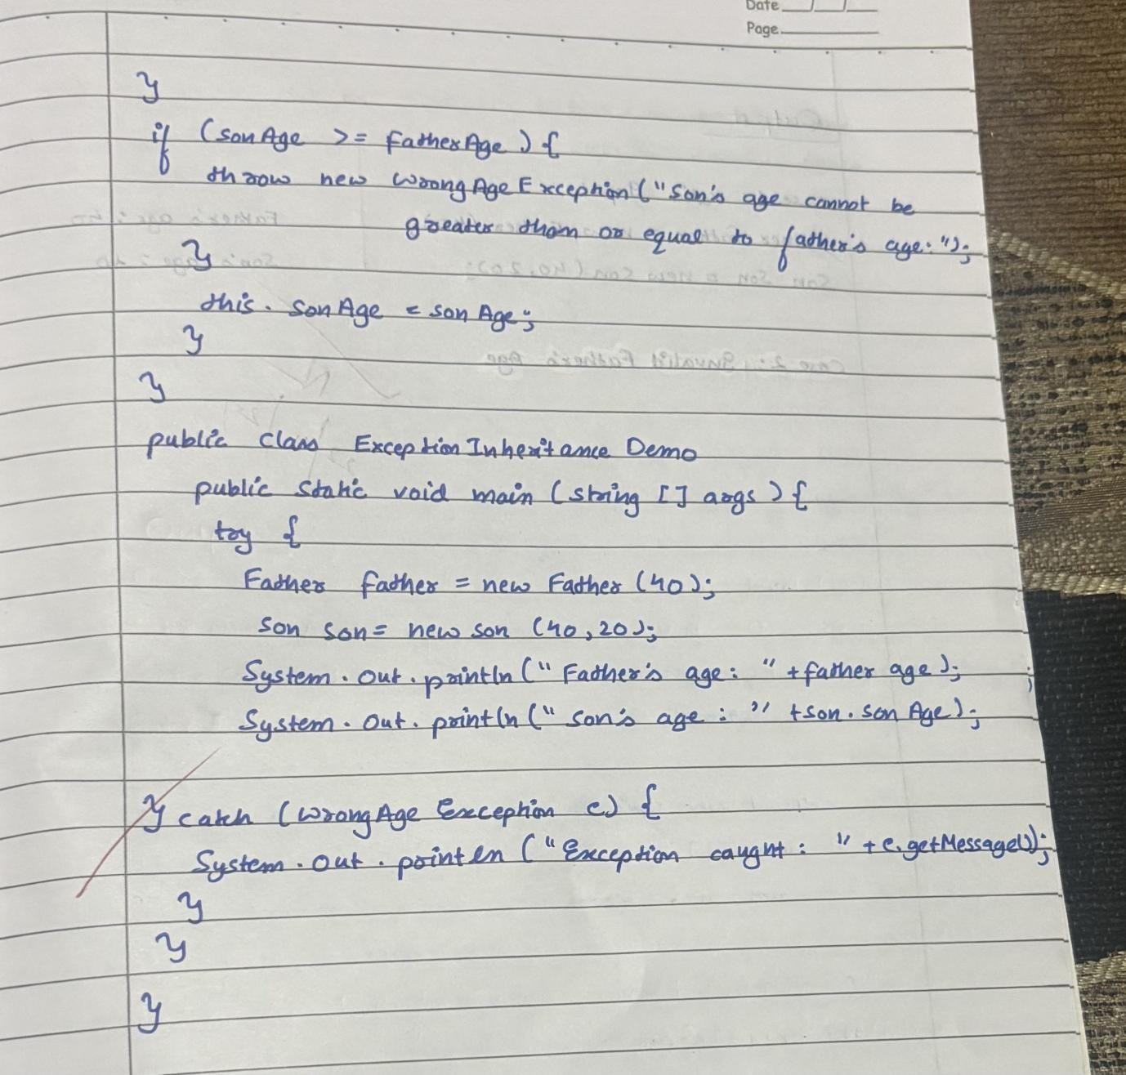

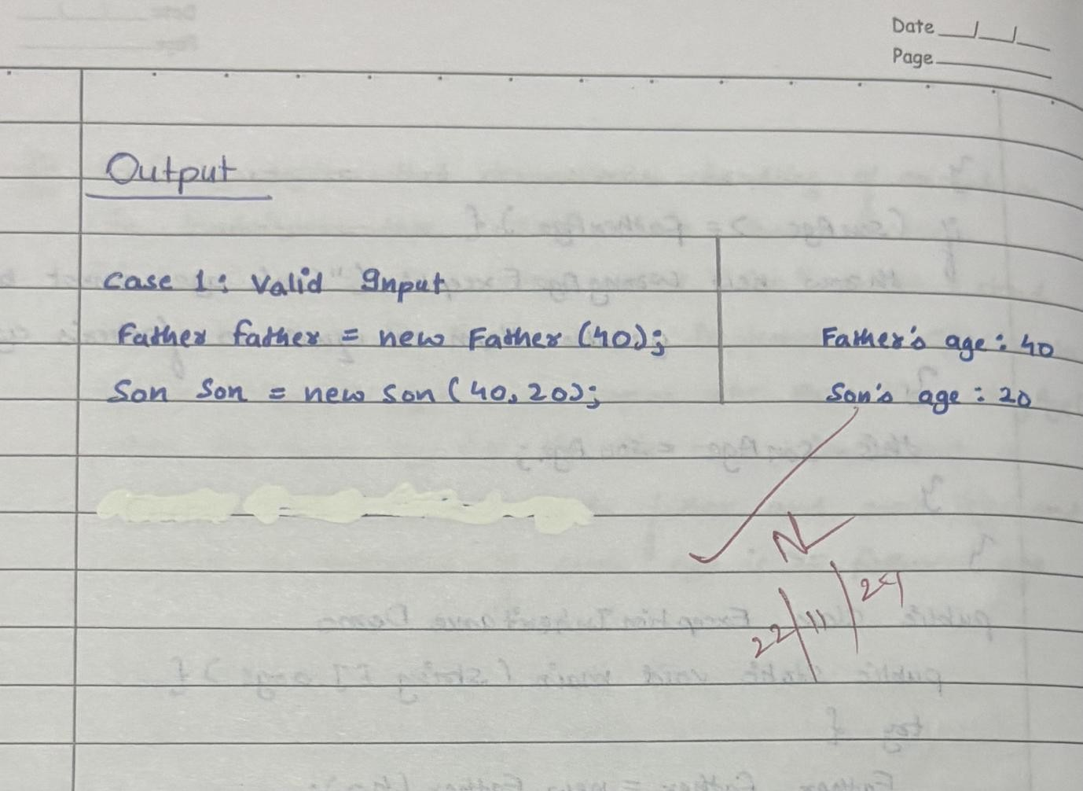

class WrongAge extends Exception { public WrongAge(String message) {

super(message);

}

}

class Father { int age;

public Father(int age) throws WrongAge { if (age < 0) {

throw new WrongAge("Age cannot be negative for Father.");

}

this.age = age;

System.out.println("Father's age is " + this.age);

}

}

class Son extends Father { int sonAge;

public Son(int fatherAge, int sonAge) throws WrongAge {

super(fatherAge);

if (sonAge >= fatherAge) {

throw new WrongAge("Son's age cannot be greater than or equal to Father's age.");

}

this.sonAge = sonAge;

System.out.println("Son's age is " + this.sonAge);

}

}

public class Age {

public static void main(String[] args) {

try {

Father father1 = new Father(-5);

} catch (WrongAge e) { System.out.println("Error: " + e.getMessage());

}

try {

Son son1 = new Son(40, 45);

} catch (WrongAge e) { System.out.println("Error: " + e.getMessage());

}

try {

Son son2 = new Son(40, 30);

} catch (WrongAge e) { System.out.println("Error: " + e.getMessage());

}

}

}

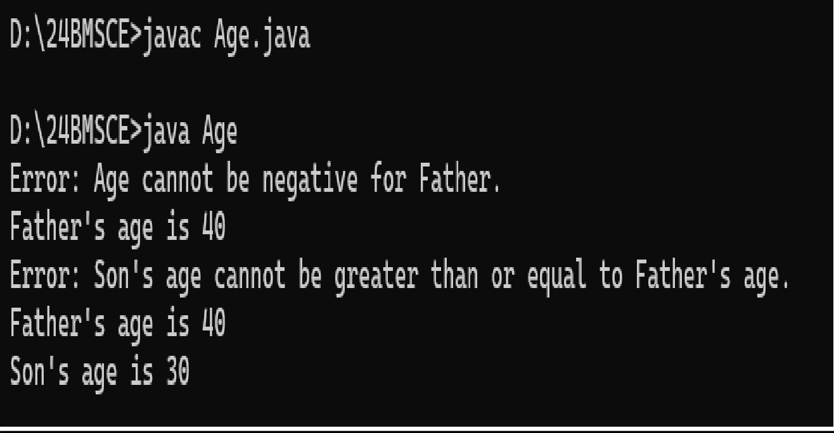

**LAB 08**

### Write a program which creates two threads, one thread displaying “BMS College of Engineering” once every ten seconds and another displaying “CSE” once every two seconds.

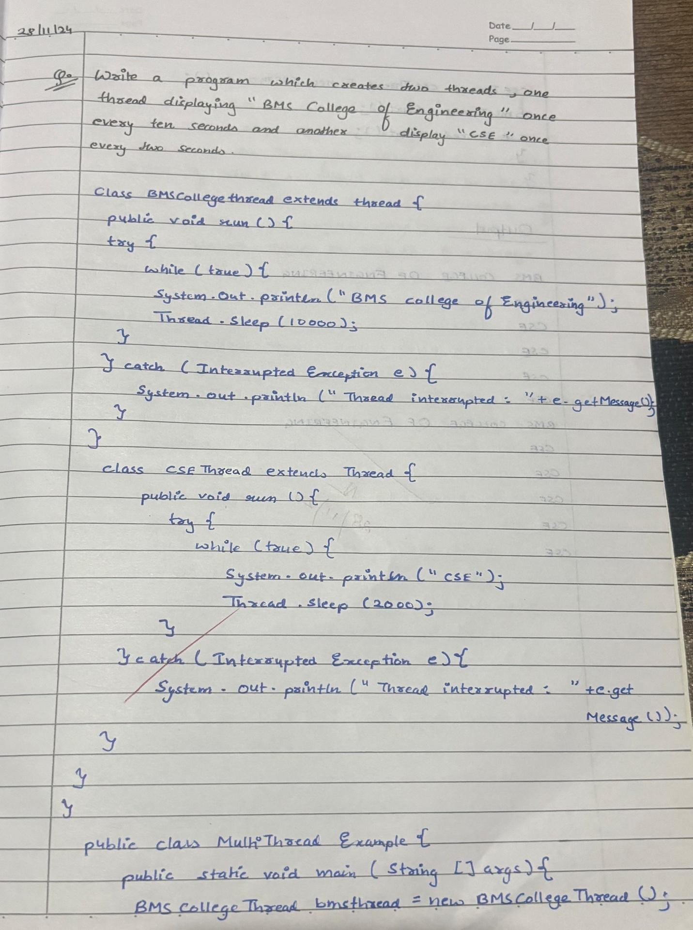

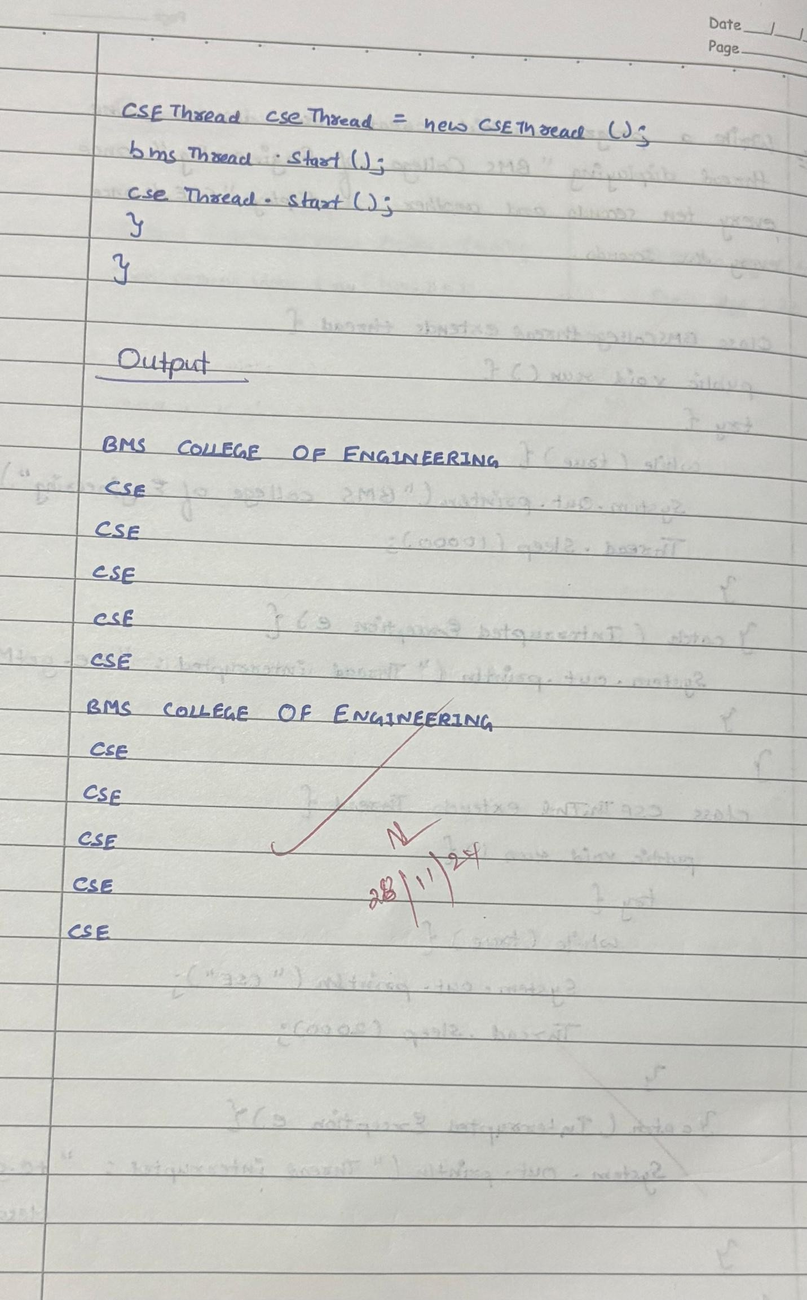

class BMSCollegeThread extends Thread { public void run() {

try {

while (true) {

System.out.println("BMS College of Engineering"); Thread.sleep(10000);

}

} catch (InterruptedException e) {

System.out.println("Thread interrupted: " + e.getMessage());

}

}

}

class CSEThread extends Thread { public void run() {

try {

while (true) { System.out.println("CSE"); Thread.sleep(2000);

}

} catch (InterruptedException e) {

System.out.println("Thread interrupted: " + e.getMessage());

}

}

}

public class MultiThreadExample { public static void main(String[] args) {

BMSCollegeThread bmsThread = new BMSCollegeThread();

CSEThread cseThread = new CSEThread();

bmsThread.start(); cseThread.start();

}

}

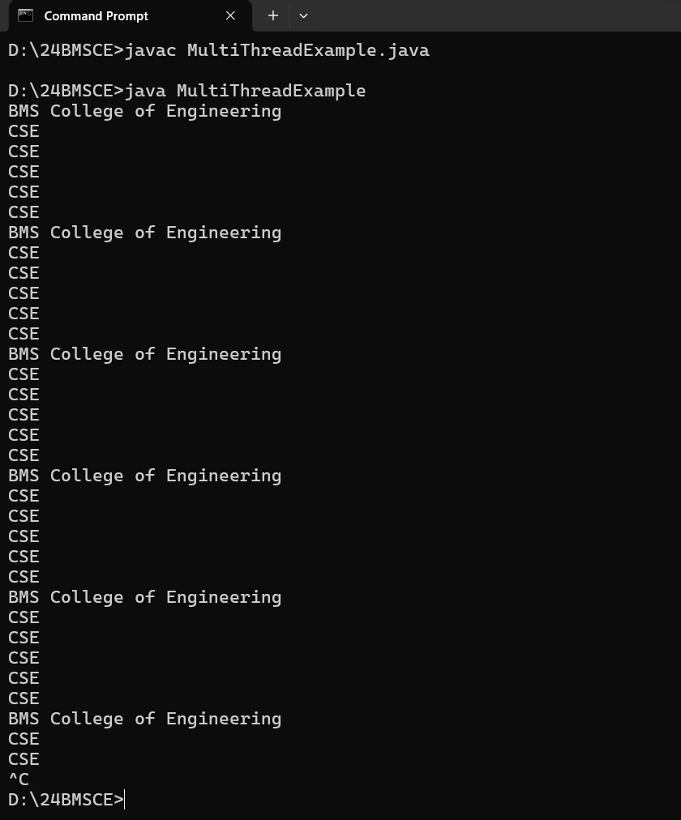

# LABORATORY PROGRAM - 9

Write a program that creates a user interface to perform integer divisions. The user enters two numbers in the text fields, Num1 and Num2. The division of Num1 and Num2 is displayed in the Result field when the Divide button is clicked. If Num1 or Num2 were not an integer, the program would throw a NumberFormatException. If Num2 were Zero, the program would throw an Arithmetic Exception Display the exception in a message dialog box.

**import java.awt.*; import java.awt.event.*;**

**public class DivisionMain1 extends Frame implements ActionListener**

{

**TextField num1,num2; Button dResult; Label outResult;**

**String out=""; double resultNum; int flag=0;**

**public DivisionMain1()**

{

**setLayout(new FlowLayout());**

**dResult = new Button("RESULT");**

**Label number1 = new Label("Number 1:",Label.RIGHT); Label number2 = new Label("Number 2:",Label.RIGHT); num1=new TextField(5);**

**num2=new TextField(5);**

**outResult = new Label("Result:",Label.RIGHT);**

**add(number1); add(num1); add(number2**

**);**

**add(num2); add(dResult); add(outResul t);**

**num1.addActionListener(this); num2.addActionListener(this); dResult.addActionListener(this); addWindowListener(new WindowAdapter()**

{

**public void windowClosing(WindowEvent we)**

{

**System.exit(0);**

}

});

}

**public void actionPerformed(ActionEvent ae)**

{

**int n1,n2; try**

{

**if (ae.getSource() == dResult)**

{

**n1=Integer.parseInt(num1.getText()); n2=Integer.parseInt(num2.getText());**

**/*if(n2==0)**

**throw new ArithmeticException();*/ out=n1+" "+n2+" ";**

**resultNum=n1/n2; out+=String.valueOf(result**

**Num); repaint();**

}

}

**catch(NumberFormatException e1)**

{

**flag=1;**

**out="Number Format Exception! "+e1; repaint();**

}

**catch(ArithmeticException e2)**

{

**flag=1;**

**out="Divide by 0 Exception! "+e2; repaint();**

}

}

**public void paint(Graphics g)**

{

**if(flag==0) g.drawString(out,outResult.getX()+outResult.getWidth(),outRes ult.getY()+outResult. getHeight()-8);**

**else g.drawString(out,10 0,200); flag=0;**

}

Demonstrate Interprocess communication and deadlock class Q {

int n;

boolean valueSet = false;

synchronized int get() { while(!valueSet)

try {

System.out.println("\nConsumer waiting\n"); wait();

} catch(InterruptedException e) { System.out.println("InterruptedException caught");

}

System.out.println("Got: " + n); valueSet = false;

System.out.println("\nIntimate Producer\n"); notify();

return n;

synchronized void put(int n) { while(valueSet)

try {

System.out.println("\nProducer waiting\n"); wait();

} catch(InterruptedException e) { System.out.println("InterruptedException caught");

}

this.n = n; valueSet = true;

System.out.println("Put: " + n); System.out.println("\nIntimate Consumer\n"); notify();

}

}

class Producer implements Runnable { Q q;

Producer(Q q) { this.q = q;

new Thread(this, "Producer").start();

}

public void run() { int i = 0; while(i<15) { q.put(i++);

}

}

}

class Consumer implements Runnable { Q q;

Consumer(Q q) { this.q = q;

new Thread(this, "Consumer").start();

}

public void run() {

int i=0; while(i<15) { int r=q.get();

System.out.println("consumed:"+r); i++;

}

}

}

class PCFixed {

public static void main(String args[]) { Q q = new Q();

new Producer(q); new Consumer(q);

System.out.println("Press Control-C to stop.");

}

}

# OUTPUT

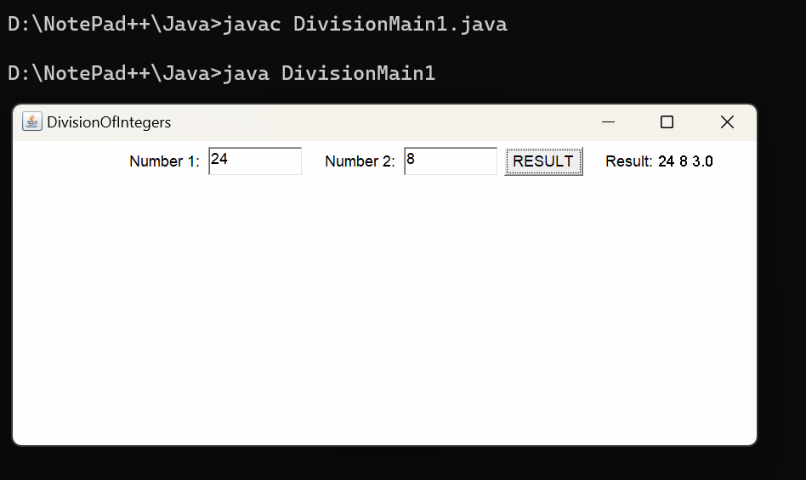

ii. Demonstration of deadlock

class A

{

synchronized void foo(B b)

{ String name = Thread.currentThread().getName(); System.out.println(name + " entered A.foo");

try { Thread.sleep(1000); }

catch(Exception e) { System.out.println("A Interrupted"); } System.out.println(name + " trying to call B.last()"); b.last(); } synchronized void last() { System.out.println("Inside A.last"); }

}

class B {

synchronized void bar(A a) {

String name = Thread.currentThread().getName(); System.out.println(name + " entered B.bar");

try { Thread.sleep(1000); }

catch(Exception e) { System.out.println("B Interrupted"); } System.out.println(name + " trying to call A.last()"); a.last(); } synchronized void last() { System.out.println("Inside A.last"); }

}

class Deadlock implements Runnable

{

A a = new A(); B b = new B(); Deadlock( ) {

Thread.currentThread().setName("MainThread"); Thread t = new Thread(this, "RacingThread"); t.start(); a.foo(b); // get lock on a in this thread. System.out.println("Back in main thread

}

public void run() { b.bar(a); // get lock on b in other thread. System.out.println("Back in other thread");

}

public static void main(String args[]) { new Deadlock(); }

}

**public static void main(String[] args)**

{

**DivisionMain1 dm=new DivisionMain1(); dm.setSize(new Dimension(800,400)); dm.setTitle("DivisionOfIntegers"); dm.setVisible(true);**

}

}